Training vs. Testing

|  |  |  |
| --- | --- | --- |
| Jan Carlo D. Rabacca  11106344 | Suzette Dela Cruz  11118113 | Marc Janssen Chiu  11114525 |

# Introduction

The optimized linear regression from the minFunc package introduces another approach in plotting the points, the optimized version plots multiple points rather than a straight line to show the general trend of the data.

# Procedures

1. Follow the procedures available on the following link below.



1. On the procedure given, put the following code on the linear_regression.m (see Fig.1).

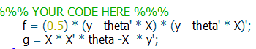

Fig. 1

1. There is an issue in ex1a_linreg.m, modify line 46 with the following code to fix it.



Fig. 2

# Data and Results

## Resulting Plot

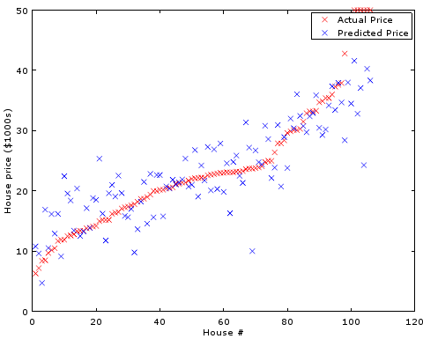

Fig. 3 House price vs. House #

# Analysis and conclusion

The previous implementation of linear regression plots a straight line to show the general trend of the data however, in the optimized implementation of the linear regression, the plot shows multiple points rather than a straight line to follow the general trend.

In conclusion, the optimized linear regression minimizes the cost J function by explicitly taking the derivatives with respect to the thetas and setting them to zero [3]. Compared with the iterative algorithm executed by the gradient descent, the optimized linear regression produces prediction that are improved and more likely closer to the desired output.

# REFERENCES

1. Ufldl.stanford.edu, 'Unsupervised Feature Learning and Deep Learning Tutorial', 2015. [Online]. Available: http://ufldl.stanford.edu/tutorial/supervised/LinearRegression/. [Accessed: 14- Oct- 2015].Quora.com, 'What is regularization in machine learning? - Quora', 2015. [Online]. Available: https://www.quora.com/What-is-regularization-in-machine-learning. [Accessed: 29- Sep- 2015].
2. GitHub, ''lbfgsAddC' undefined · Issue #3 · amaas/stanford_dl_ex', 2014. [Online]. Available: https://github.com/amaas/stanford_dl_ex/issues/3. [Accessed: 14- Oct- 2015].
3. 2015. [Online]. Available: http://cs229.stanford.edu/notes/cs229-notes1.pdf. [Accessed: 14- Oct- 2015].